Assessment II

I completed my second assessment ‘birthday greetings’

Requirements:
Python – 2.7.9
Django – 1.10

Install:
pip
sublime text 2

To test the server - Mail send :
~”file path”/python manage.py send_daily_birthday_wishes

To run the server:
python manage.py runserver

crontab:
crontab -e

“ 30 * * * */usr/bin/python/home/linuxuser/Desktop/birthday_application/manage.py send_daily_birthday_wishes “

Assessment Question:

Create an birthday application in django python. That application might contains the scheduled remainder alert for birthday notifications. Don't spend much time in create, delete and update for employee details took it manually in database and work on remained part of work in that application.

I splited the concept in my birthday application :

step 1: create a database
step 2: put the employee details, after this details store in database
step 3: check the date of birth ‘today whose birthday’ in database next send the mail to all the employees except birthday employees.

Next,
I followed this steps, first i created DB and i registered the employee details, after this details store in database using templates, and i set the buttons such as (add new employee, delete, and birthday employees using HTML.

After i created check the date of birth ‘today whose birthday’ in database next send the mail (message - Today is “employee_name” birthday) to all the employees except birthday employees. And again send another mail (message – Happy Birthday “birthday_employee_name) to birthday employees only.

Note:
give your mail ID and your password in (EMAIL_HOST_USER , EMAIL_HOST_PASSWORD) in settings in this application, after execute this application
commend line to be added in crontab:
crontab command,

[ 30 * * * * /usr/bin/python /home/linuxuser/Desktop/birthday_application/manage.py send_daily_birthday_wishes ]
so, my application mail will be sending every 30 min automatically in my system.

My application views:

* Run server: python manage.py runserver
* Display link: 127.0.0.1.8000
* give this link in url and add mymail
Ex: 127.0.0.1.8000/mymail/

View Employee List:

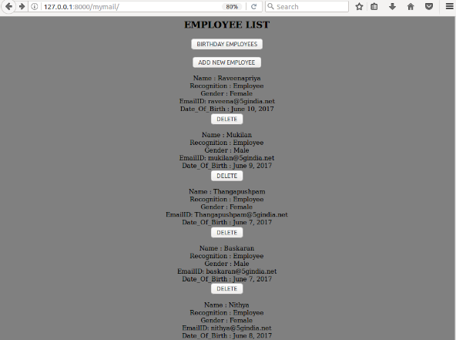
Add_New_Employees:

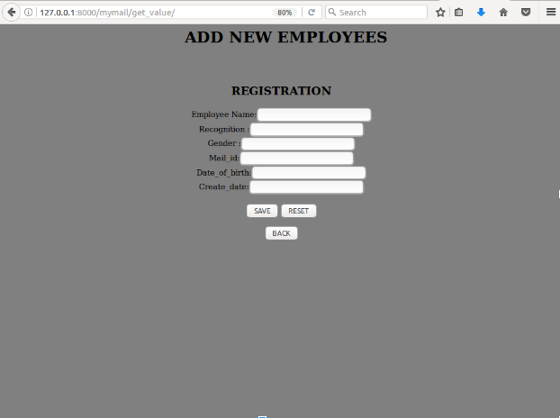
Run server: My path/python manage.py send_daily_birthday_wishes and click birthday employees button
Display: Birthday Employees

